Appendix 1: 14/02399/FUL & 2396/LBD, St John’s College, Oxford

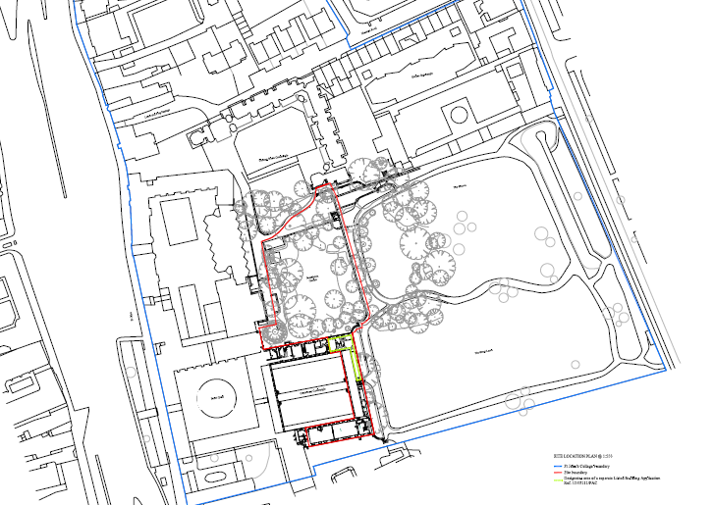
St Giles

